University of Dayton

ECE

Mumma Radar Lab

Comprehensive VHDL

Fall 2016

Midterm

FIR Filter Design

Due on Monday 10/24/2016

Design Finite Impulse Response (FIR) filter (Non-recursive digital filter) with 37 coefficients (taps) in VHDL.

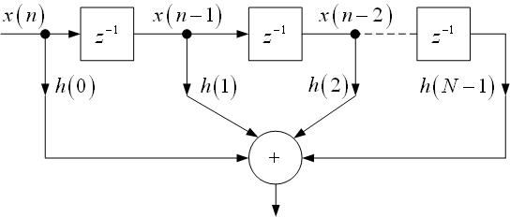

FIR Filter

Please use the following coefficients:

146, 283, 439, 501, 345, - 134, -966, -2041, -3081, -3661, -3293, - 1549, 1788, 6610, 12440, 18482, 23773, 27393, 28680, 27393, 23773, 18482, 12440, 6610, 1788, - 1549, -3293, -3661, -3081, -2041, -966, - 134, 345, 501, 439, 283, 146

Hints:

You can optimize your design to be a symmetric FIR filter:

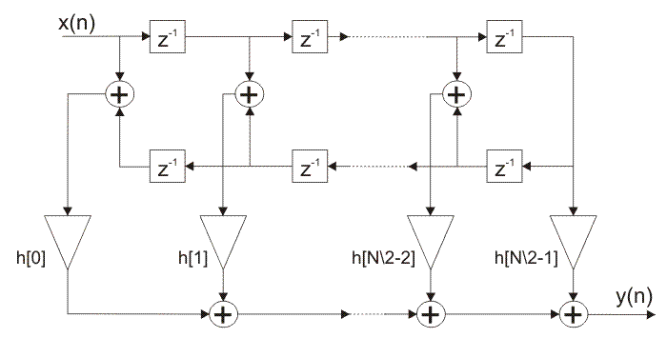

Symmetric FIR Filter

Steps:

You may use the following steps:

All integers shall be signed.

All addition results shall saturate.

Rounding is to be via truncation which shall result in rounding towards negative infinity.

The following format 16Q15 is specifies a signed integer of width 16 and 15 bits to the right of the decimal point.

Here are the steps:

1 = your input data.  It is of the format 16Q15

2 = is a delay block.  The data format is not changed through this block

3 = The last input sample (it has been delayed)

4 = accumulator.  It takes in two 16Q15 integers and adds with saturation to result in a 17Q15 integer.

5 = first accumulator output of the data type 17Q15

6 = First coefficient multiplier.  The coefficient is an integer stored in format 16Q17. The multiplier multiplies a 17Q15 with a 16Q17 to yield an initial result of 33Q32.  The 33Q32 results is right-shifted by 14 bits to yield a 19Q18 result.

7 = Result of multiplier labeled by “6” with an integer format of 19Q18.

8 = accumulator.  It takes in two 19Q18 integers and adds with saturation to result in a 20Q18 integer.

9 = result of accumulator labeled by “8”

10 = accumulator.  It takes in a 19Q18 and a 20Q18 integer and adds with saturation to result in a 20Q18 integer.

11= conversion to final output format.  20Q18 is input and 16Q15 is output.  Conversion occurs by outputting Bits 18-3 or by right-shifting by 3 and ignoring the MSB.

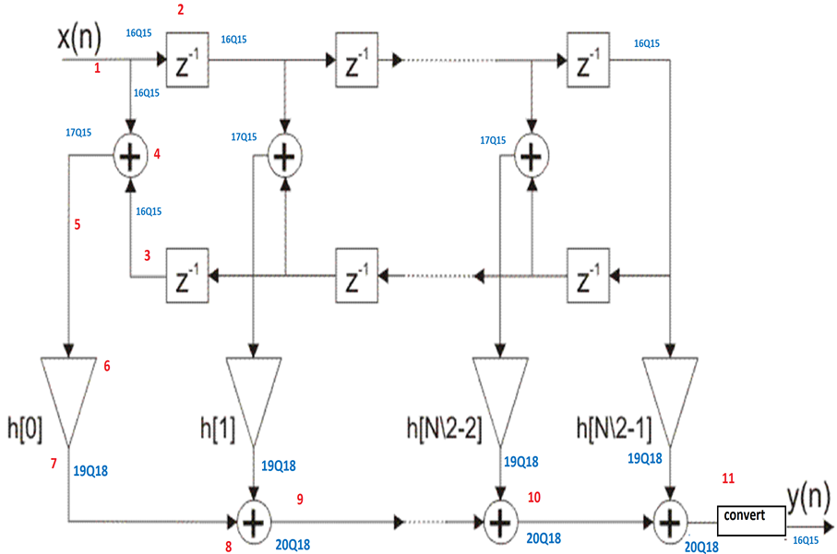

Please use the following entity:

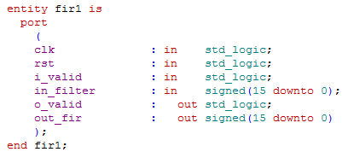

You will be given the input data (data needs to be filtered) in a text file. And you should get the filtered data (out filter) in a text file when you run your simulation.

Please plot the data before and after the filtering. You should get something like:

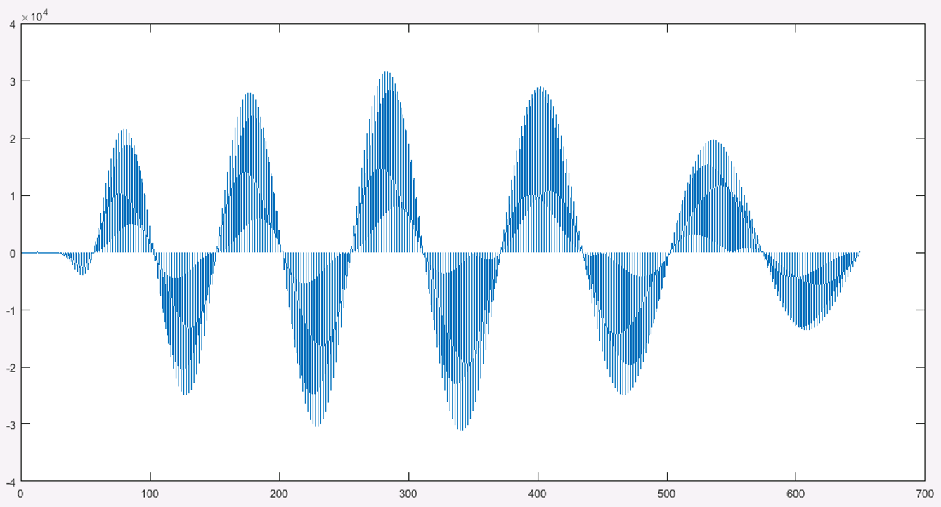

Data before filtering

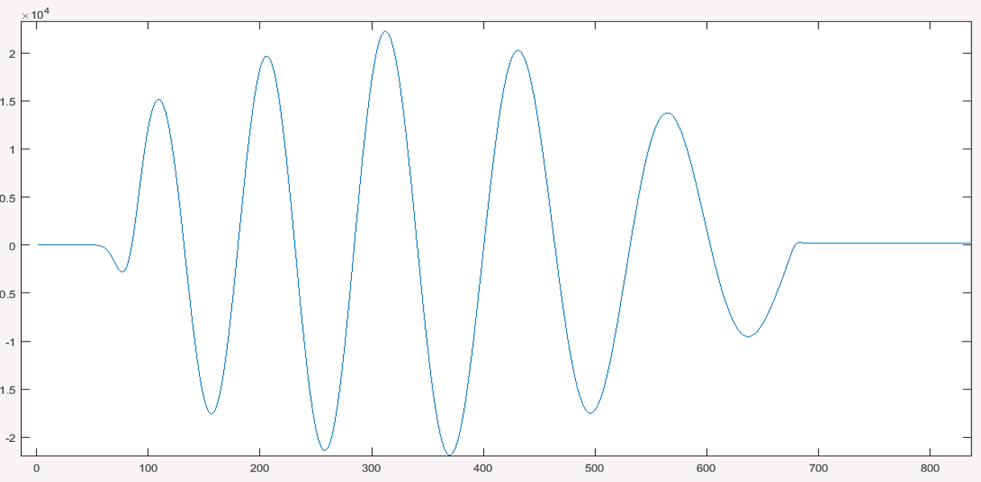

Data after filtering

Please submit:

1. Report
2. Main code
3. TB code
4. TCL file
5. Output file – a text file that is created by your TB-